**Use of Mobile Application Frameworks: React Native**

Oxford Oli

Presidential Graduate School, Thapagaun, Kathmandu

PRG 402: Mobile Programming Applications

Prof. Abiral Khanal

Sep 26, 2025

Figure 1  
*Simulate splash screen for 5 seconds*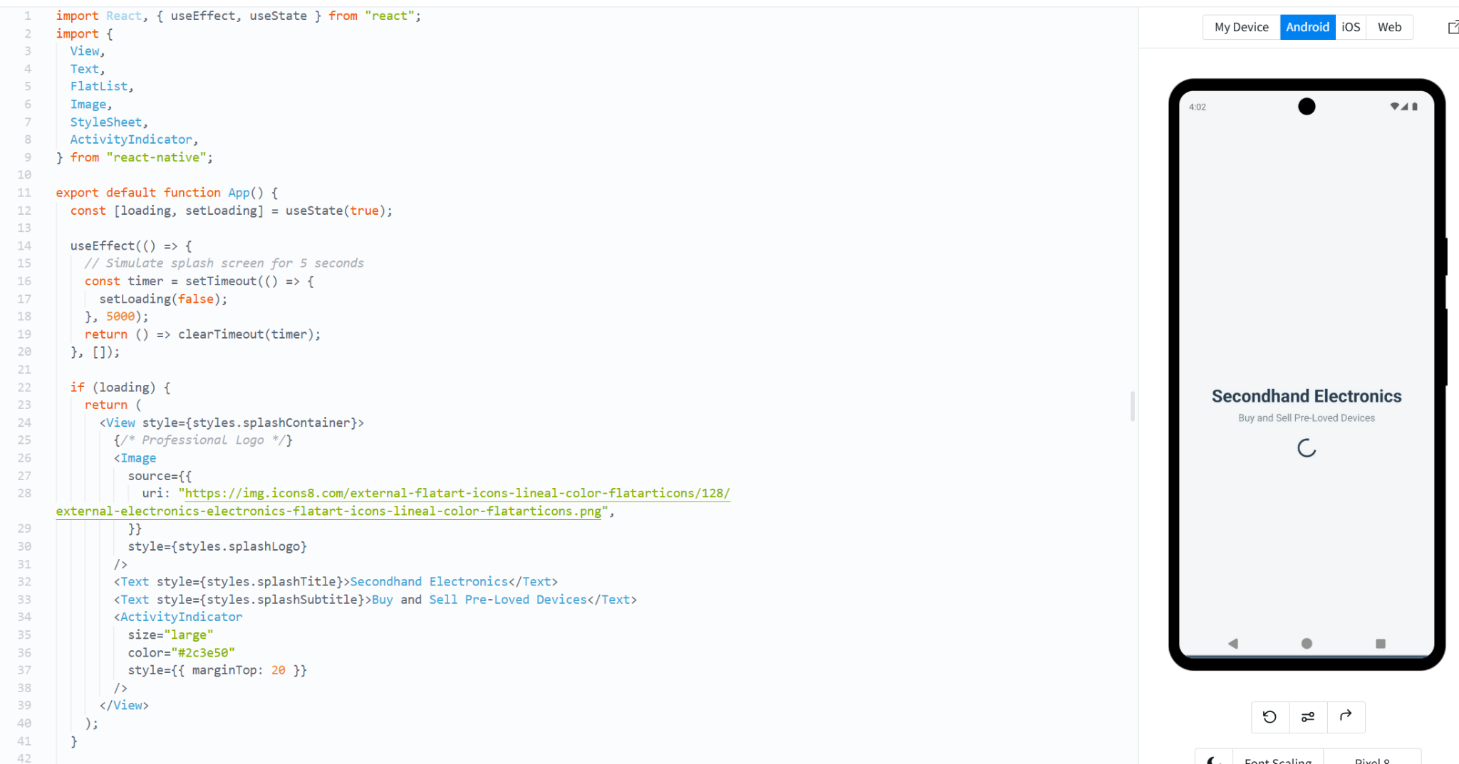

Note: React Native code created using snack.expo.dev, 2025.

Figure 2  
*Main Marketplace after splash*

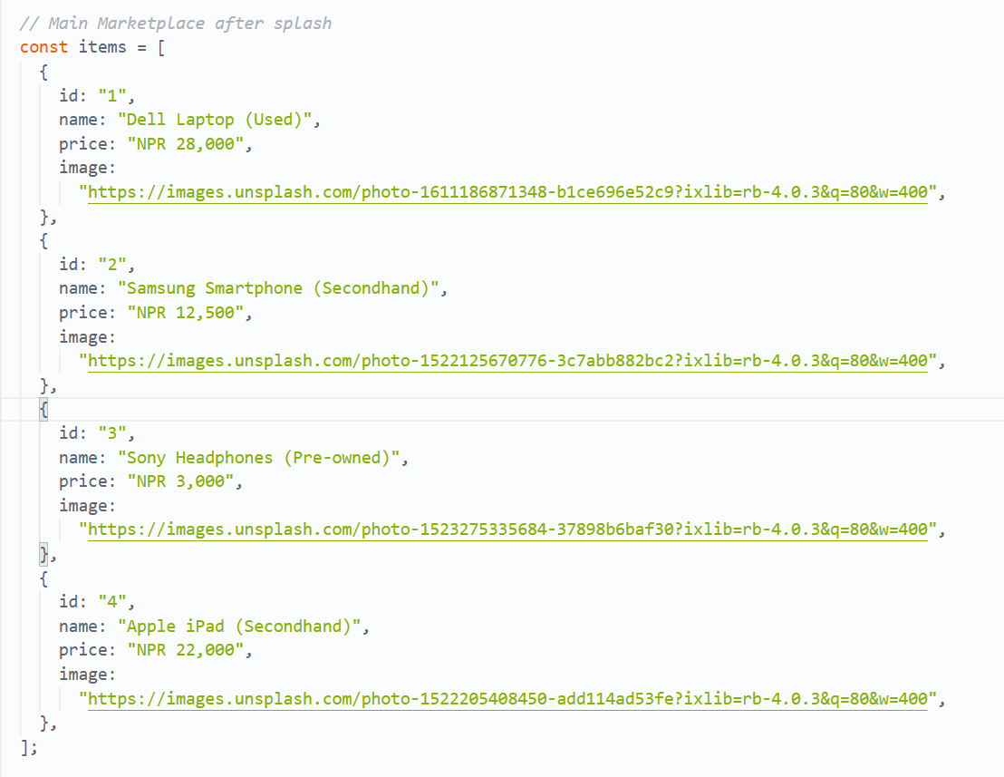

Note: React Native code created using snack.expo.dev, 2025.

Figure 3

*Logo*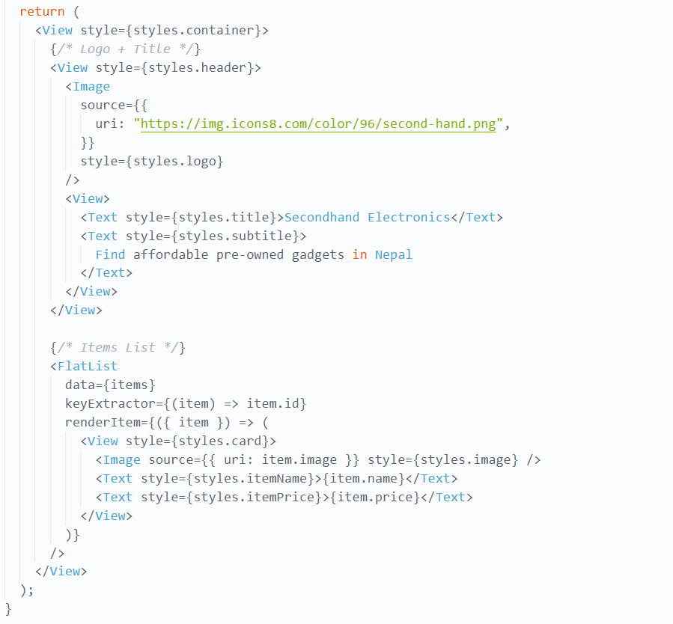

Note: React Native code created using snack.expo.dev, 2025.

Figure 4  
*Splash Styles*

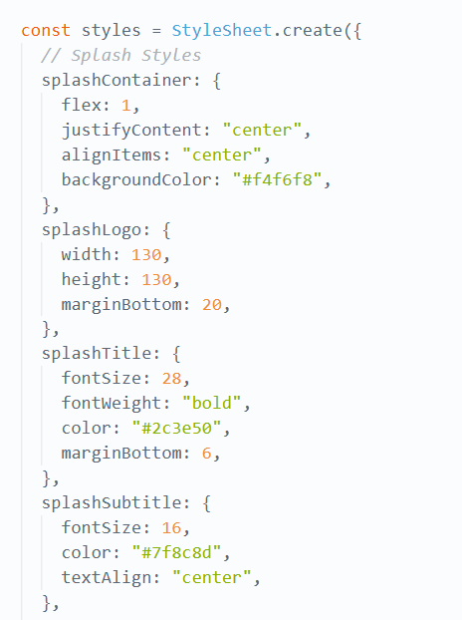  
Note: React Native code created using snack.expo.dev, 2025.

Figure 5  
*Marketplace Styles*

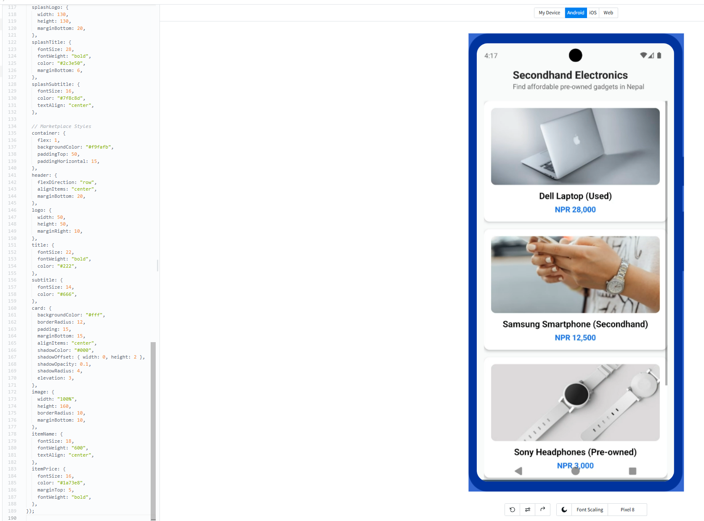

Note: React Native code created using snack.expo.dev, 2025.

Explanation of the Code

The current program is written in React Native, which is a mobile application framework, with which application developers can write Android and iOS apps through JavaScript. The online development platform we selected was Expo Snack, which allowed the online operation of the app in a simulator. Using the code, I have learned how to create a secondhand electronics marketplace using a splash screen and a product listing page.

1. Splash Screen

The app begins with a splash screen for 5 seconds. It is managed with the help of the useState and useEffect hooks:

* The loading state will be true to start with.
* The useEffect with a setTimeout of 5 seconds will only complete after the allotted time, and loading will be false.
* Although it is true that loading occurs, the loading screen has a logo, title, subtitle, and a loading spinner (ActivityIndicator).

This emulates a professional start-up screen prior to loading the actual application.

2. Marketplace Home Page

The opening screen of the app displays the primary marketplace. This page has two parts:

* It consists of a Header Section that contains a small logo, the title of the app, which is Secondhand Electronics, and a subtitle that explains the content of the app.
* A FlatList-based Product List. The items array will have goods (e.g., Dell Laptop, Samsung Smartphone, Sony Headphones) that include their names, prices in Nepali Rupees ( NPR ), and their images. View, image, and text have been used to display each product in a card format.

3. Responsive Components and Styling React Native.

React Native gives default elements of a user interface, including View, Text, Image, FlatList, and ActivityIndicator. Its StyleSheet tool is StyleSheet.create as opposed to CSS. This is what makes the UI unified in Android and iOS. The app features rounded corners, shadows, and spacing that give it a modern and professional appearance.

**References***Snack - React Native in the browser*. (n.d.). Expo. <https://snack.expo.dev/?platform=android>